Bug Report

<http://qainterview.pythonanywhere.com/>

* The application doesn’t respond to negative integers (-9) - no result or message shown to user on screen. A 500 internal server error is shown in the console
* Integers above 990 give a 500 internal server error in console - no information shown to user on screen. (Screenshot 1 below)
* Entering 0. does not display a message to the user asking to only enter integers - shows 500 internal server error in console
* Web browser tab has a typo - 'Factoriall' should be 'Factorial' (Screenshot 2)
* 'Enter' button does not submit the request to calculate – normally this is expected functionality
* Numbers above 171 give a result of 'Infinity' - not an error depending on the requirements (Screenshot 3)
* Terms and Conditions text links to Privacy document - document not ready and displays a fail to load error in console
* Privacy document links to Terms and Conditions - document not ready and displays a fail to load error in console
* I think *"© Qxf2 Services 2022 - 2022*" should just be "*© Qxf2 Services 2022*" (Screenshot 4)

Screenshot 1

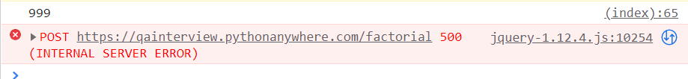

Screenshot 2



Screenshot 3

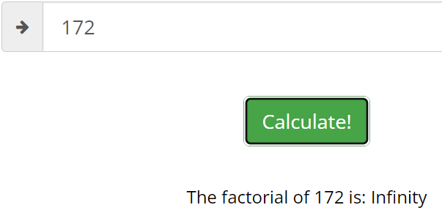

Screenshot 4

